**Perinatal Services Update**

February 3, 2025

_____________________________________________________________________________________

**Save the Date Announcements**

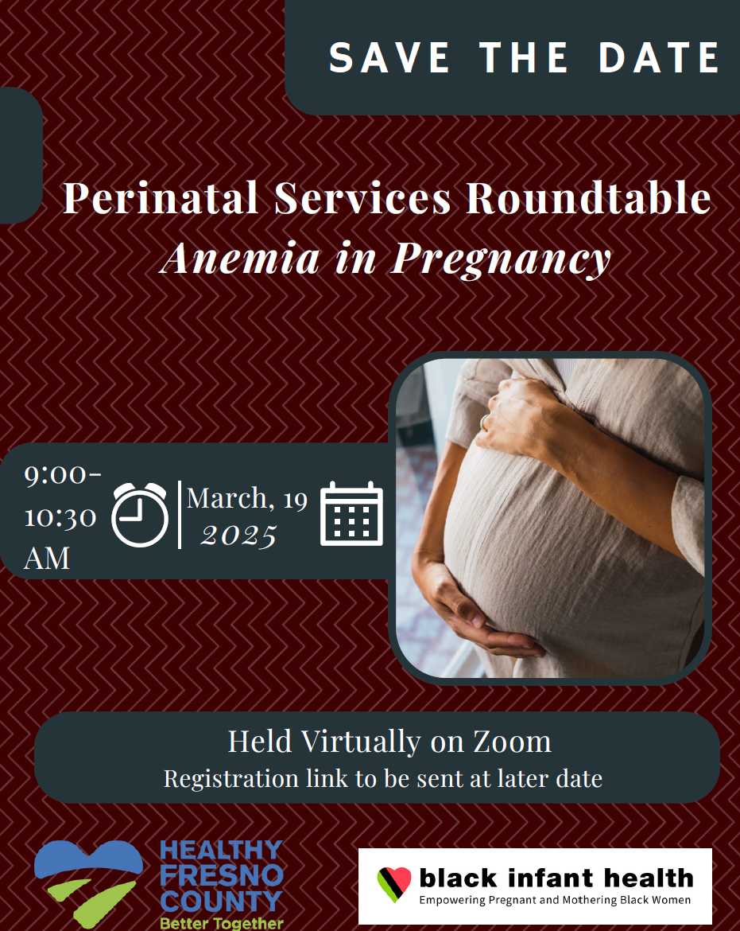

Perinatal Services Roundtable addressing Anemia in Pregnancy on Wednesday, March 19, 2025.

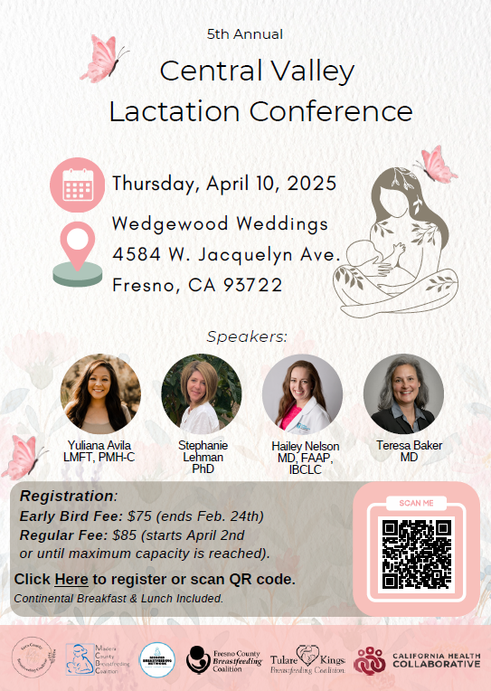

Central Valley Lactation Conference Thursday, April 19, 2025

**_______________________________________**

**News**

February is American Heart Health month, and we have a message from the American Heart Association (AHA):

Cardiovascular disease is the number 1 killer of new moms. Pregnancy-related deaths in the U.S. have risen nearly 140% over the last three decades – cardiovascular disease continues to be the leading cause. To combat this, the AHA is increasing education and awareness, advancing science and research, driving policy and systems change, improving clinical care, and organizing community-focused health programs.

To learn more about women’s risk of cardiovascular disease and empower yourself to prevent or manage it, please visit <https://www.goredforwomen.org/en/>. Spanish-language materials are available at <https://www.goredforwomen.org/es/> .

Feel free to reach out to Community Impact Consultant, Jacob Pennington ([Jacob.pennington@heart.org](mailto:Jacob.pennington@heart.org)), to connect directly with the AHA team in the Central Valley to learn more about our local efforts to support outpatient clinics, share your ideas for new projects, and find out about opportunities to volunteer your time or expertise locally.

Jacob Pennington, MPH

Region Sr Community Impact Consultant

Western States

American Heart Association

Mobile 808.294.9278

_______________________________________

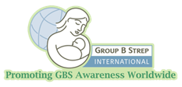

February is also International Prenatal Infection Prevention Month. This is a worldwide observance to bring awareness to infections that can be transmitted from mother to baby. Learn more about early prenatal care, vaccinations, good hygiene, and proper food handling at [Group B Strep International](https://www.groupbstrepinternational.org/february-is-international-prenatal-infection-awareness-month.html#:~:text=February%20is%20International%20Prenatal%20Infection%20Prevention%20Month).

_______________________________________

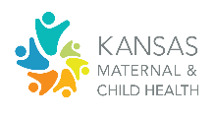

Kansas Maternal & Child Health has developed an action alert and social media graphics in recognition of February as Prenatal Infection Prevention Month. Visit <https://www.kansasmch.org/prenatal-infection-awareness.asp> to learn more.

**____________________________________**

**Opportunities to Get Involved**

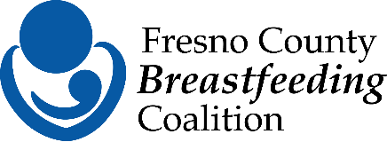

The Fresno County Breastfeeding Coalition is on a mission to empower families to successfully meet their breastfeeding/chest feeding goals through advocacy, education, and promotion. We're currently looking for a passionate Co-Chair and Secretary to join this dynamic, impact-driven team! If you're interested or want to learn more about the coalition and how you can support our efforts, reach out to [fresnobreastfeeds@gmail.com](mailto:fresnobreastfeeds@gmail.com). Let's work together to make a lasting difference in our community!

Please take a quick survey regarding Gestational Diabetes Mellitus (GDM) at <https://www.surveymonkey.com/r/HJN2Q7Q>

Gestational diabetes mellitus (GDM) is often treated as a temporary condition during pregnancy, but it can have lasting effects on women’s’ health.

[Persistence of Risk for Type 2 Diabetes After Gestational Diabetes Mellitus](https://pmc.ncbi.nlm.nih.gov/articles/PMC9016728/)

**_______________________________________**

**Community Resources**

[Fresno Mission](https://www.fresnomission.org/) offers a variety of services to meet the most basic and immediate needs.

_______________________________________

Centro La Familia provides services that empower and support families and individuals in our culturally diverse community. Learn more at <https://www.centrolafamilia.org/services/>

**_______________________________________**

**Provider Resources**

California Health Collaborative’s CalAIM Enhanced Care Management (ECM) program is committed to delivering whole-person care and support to Medi-Cal recipients with complex health needs throughout Fresno County. Our services include case management, educational resources, home visits, and connecting individuals to essential community resources, such as food assistance, housing, infant supplies, and other critical services.

We are excited for the opportunity to partner with community providers like you to offer more holistic, integrated care that fosters long-term health for our most vulnerable populations.

For more information about our program or to refer an individual, please call 888-752-6777 or email [CalAIM@healthcollaborative.org](mailto:CalAIM@healthcollaborative.org).



_______________________________________

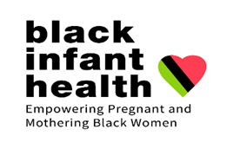

Black Infant Health (BIH)

BIH is a unique program that provides support within a culturally affirming environment, honoring the unique history of African American women.

Women can be referred by their doctors, school nurses, Fresno County outreach workers, public health nurses or self-referral.

Provider Referral

[Public Health Nursing Referral Form](https://www.fresnocountyca.gov/files/assets/county/v/1/public-health/public-health-nursing/phn-services-ref-form.pdf%20)

Fill out form and fax to (559) 455-4705 or

email to [phnfax@fresnocountyca.gov](mailto:phnfax@fresnocountyca.gov).

Self-Referral

In office: 142 E. Cesar Chavez Blvd, Fresno, CA 93706

By phone: (559) 600-1021

Email: [bih@fresnocountyca.gov](mailto:bih@fresnocountyca.gov)

[Facebook Fresno Black Infant Health](https://www.facebook.com/FresnoBlackInfantHealth/)

_______________________________________

Learn more about general recommendations for vaccinating pregnant people with routine vaccines, travel vaccines, and other vaccines at[Guidelines for Vaccinating Pregnant Persons](https://www.cdc.gov/vaccines-pregnancy/hcp/vaccination-guidelines/?CDC_AAref_Val=https://www.cdc.gov/vaccines/pregnancy/hcp-toolkit/guidelines.html%20)

**_______________________________________**

The Perinatal Services Coordinator (PSC) continues to reach out to Comprehensive Perinatal Services Providers to schedule a meet and greet at your site and provide a resource folder with Fresno County resources and programs along with our Postpartum Heart Health Toolkit. You can also reach out to me to schedule at 559-600-6387.

Yvonne Lopez, RN, PHN, CLC

Perinatal Services Coordinator

County of Fresno

Main: 559-600-3330

Direct: 559-600-6387

Email: [yvolopez@fresnocountyca.gov](mailto:yvolopez@fresnocountyca.gov)