Perinatal Services

News, Announcements, Trainings, Resources, & Opportunities to Get Involved March 3, 2025



[This Photo](https://en.wikipedia.org/wiki/File:Shamrock_svg.svg) by Unknown Author is licensed under [CC BY-SA](https://creativecommons.org/licenses/by-sa/3.0/)



[This Photo](https://en.wikipedia.org/wiki/File:Shamrock_svg.svg) by Unknown Author is licensed under [CC BY-SA](https://creativecommons.org/licenses/by-sa/3.0/)

**Perinatal Services (PS) March Roundtable**

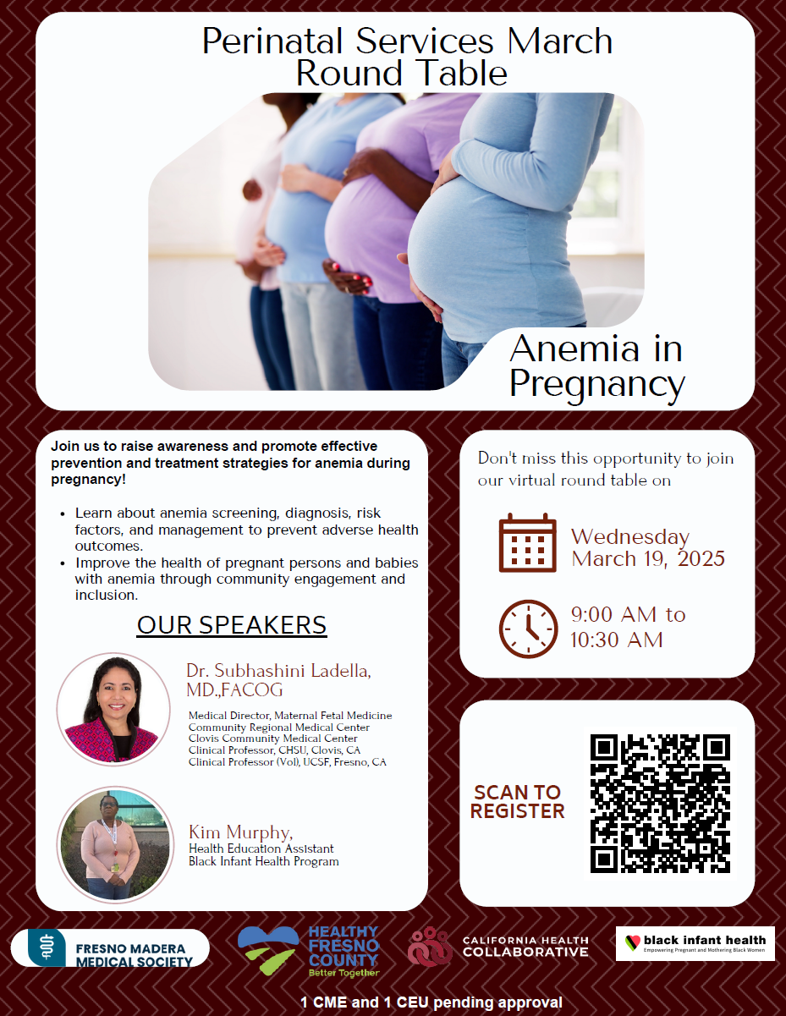

Join us March 19, 2025, to raise awareness and promote effective prevention and treatment strategies for anemia during pregnancy! Learn about anemia screening, diagnosis, risk factors and management to prevent adverse health outcomes. Improve the health of pregnant persons and babies with anemia. Register today to join our PS March Roundtable, Anemia in Pregnancy. Scan QR code to register. __________________________________________

March is [National Nutrition Month ®](https://www.eatright.org/about-national-nutrition-month)

During the month of March, everyone is invited to learn about making informed food

choices and developing healthful eating and physical activity habits. Visit <https://www.eatright.org/national-nutrition-month> to learn more about activities and resources. __________________________________________

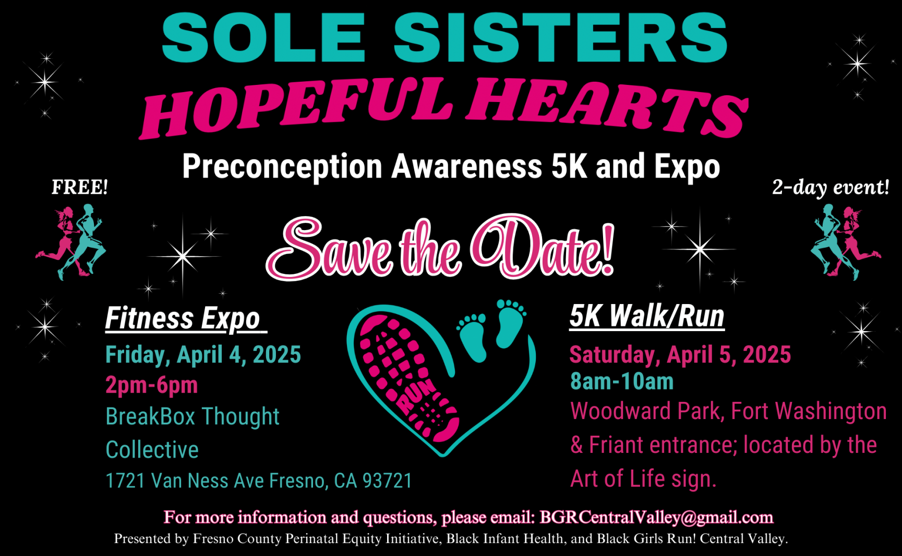

The Preconception Awareness 5K Walk/Run is to raise awareness of the vital role that preconception care plays in ensuring healthier pregnancies and improved maternal and birth outcomes, particularly in communities of color.

A 2-day Event, consisting of an expo on day 1 (April 4) featuring information booths and activities and a walk/run on the second day (April 5).

Event is FREE and open to all regardless of age and running experience. The registration link is not ready yet, but folks can email [BGRCentralValley@gmail.com](mailto:BGRCentralValley@gmail.com) for more information about the run and registration details.



[Visit Count the Kick](https://countthekicks.org/oral-health-pregnancy/) to learn about the importance of oral health in pregnancy. The importance of ensuring that your patients are not only referred but getting connected and are seen by the dentist can contribute in helping pregnant people have a healthy pregnancy.

Please contact Perinatal Services Coordinator, Yvonne Lopez, at 559-600-6387 for oral health material from Smile California.

**Provider Resources**

[Cherry Blossom Bereavement Flyer](https://uchealth.service-now.com/csp?id=kb_article&sys_id=b7ccec19db09ac107f110e85ca9619bb) discusses options of comfortably stopping breastmilk or how to possibly donate for birthing parents who have had a loss of an infant.

__________________________________________

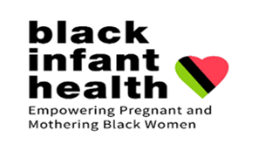

Black Infant Health (BIH) is a unique program that provides support within a culturally affirming environment, honoring the unique history of African American women.

Women can be referred by their doctors, school nurses, Fresno County outreach workers, public health nurses or self-referral.

Provider Referral:

Public Health Nursing Referral Form

Fill out form and fax to (559) 455-4705 or

email to [phnfax@fresnocountyca.gov](mailto:phnfax@fresnocountyca.gov) .

Self-Referral:

In office: 142 E. Cesar Chavez Blvd, Fresno, CA 93706

By phone: (559) 600-1021

Email: [bih@fresnocountyca.gov](mailto:bih@fresnocountyca.gov)

[Facebook Fresno Black Infant Health](https://www.facebook.com/FresnoBlackInfantHealth/)

**Community Resources**

Learn more about the grand opening of Fresno Mission’s City Center [Fresno Mission's City Center](https://citycenterfresno.org/)

__________________________________________

If you are near Selma, CA on Saturday March 22, 2025, visit the Healthy, Wealthy, and Wise Health Fair at Lincoln Park from 9:00 am-3:00 pm.

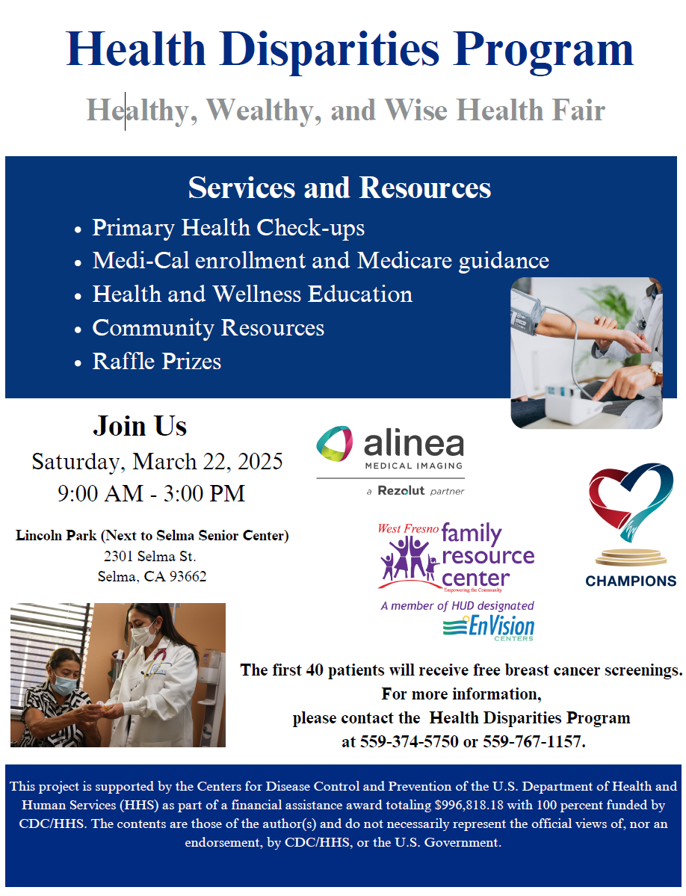

Fresno County PSC Contact information:

Yvonne Lopez, RN, PHN, CLC

Perinatal Services Coordinator

County of Fresno

Main: 559-600-3330

Direct: 559-600-6387

Email: [yvolopez@fresnocountyca.gov](mailto:yvolopez@fresnocountyca.gov)