**Perinatal Services Update**

News, Announcements, Trainings, Opportunities to Get Involved & Resources November 1, 2024

**November is Diabetes Awareness Month** Fresno County Maternal & Preventative Care Committee focuses on maternal health conditions related to the perinatal period, one of which is gestational diabetes.

Meetings are held the first Tuesday of every month from 10am-11:30am.

For more information, contact Sophia Salinas at [ssalinas@healthcollaborative.org](mailto:ssalinas@healthcollaborative.org).

_______________________________________**Upcoming Events**

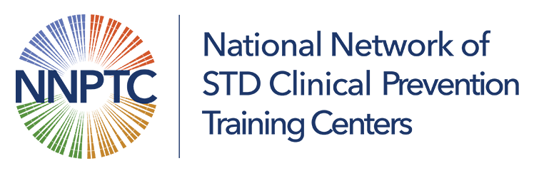STI Clinical Update Webinar: Syphilis in Pregnancy

November 20, 2024, 12:00pm-1:15pm (PST) 1.25 Continuing Medical Education (CME) units at no cost.

For more information, visit <https://courses.nnptc.org/class_information.html?id=4015>

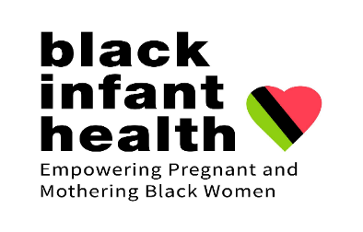

Black Infant Health (BIH)

BIH is a unique program that provides support within a culturally affirming environment, honoring the unique history of African American women. Black Infant Health aims to help African American women have healthy babies. Our weekly Sista’ Talk Circle sessions help women access their own strengths, build social support, reduce stress, increase empowerment, and set health-promoting goals for themselves and their babies.

Women can be referred by their doctors, school nurses, Fresno County outreach workers, public health nurses or self-referral.

Provider Referral

[Public Health Nursing Referral Form](https://www.fresnocountyca.gov/files/assets/county/v/1/public-health/public-health-nursing/phn-services-ref-form.pdf)

Fill out form and fax to (559) 455-4705 or

email to [phnfax@fresnocountyca.gov](mailto:phnfax@fresnocountyca.gov) .

Self-Referral

In office: 142 E. Cesar Chavez Blvd, Fresno, CA 93706

By phone: (559) 600-1021

Email: [bih@fresnocountyca.gov](mailto:bih@fresnocountyca.gov)

[Facebook Fresno Black Infant Health](https://www.facebook.com/FresnoBlackInfantHealth/)

**_______________________________________**

**Opportunities to Get Involved**

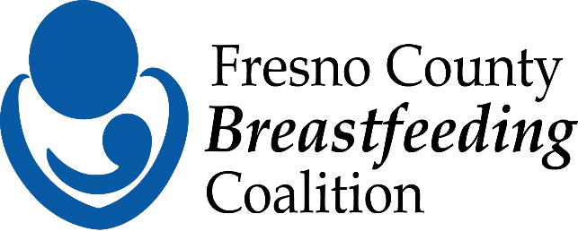Breastfeeding Coalition

The mission of the Fresno County Breastfeeding Coalition is to empower families to successfully meet their breastfeeding/chest feeding goals through advocacy, education, and promotion. To be part of this dynamic team or for more information, email [Fresnobreastfeeds@gmail.com](mailto:Fresnobreastfeeds@gmail.com)

**_______________________________________**

**Provider Resources**

Oral health is important during pregnancy and infancy. Learn how to support and connect with new parents and families regarding the importance of oral health.

[Protect Tiny Teeth Toolkit: Helping You Help Parents and Families](https://www.aap.org/en/news-room/campaigns-and-toolkits/oral-health/?srsltid=AfmBOoo2SlEl5PnC_tDt3QTWIfL2sIPGj_FHKCYzYu8B3SRcD5dqloRW)

_______________________________________**Community Resources**

Fatherhood program, Fresno Regional Workforce Development Board

Do you know a father who is 18 years and older who is interested in learning about the tools to be a better person, partner, and parent? Refer them to the fatherhood program.

Contact Yvette Rodriguez at (559) 230-4108 or [yrodriguez@workforce-connectin.com](mailto:yrodriguez@workforce-connectin.com)

**Video:** [Fatherhood Program Overview, FRWDB Workforce Connection](https://www.youtube.com/watch?v=mfM6cPHN8wc)

_______________________________________

At Shine, we empower young mothers to complete high school, persist through post-secondary education, and nurture their child’s positive development.

We believe young moms are capable of anything. We help them write their own scripts, giving them the resources and care needed to build successful lives for themselves and their children.

Shine empowers young mothers with the resources and support they need to build a successful life. By positively impacting mothers and their children, we are creating stronger families and stronger communities too.

Contact Sarah Villa at [svilla@shinetogether.org](mailto:svilla@shinetogether.org) for more information.

**_______________________________________**

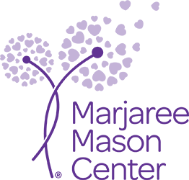

Marjaree Mason Center (MMC)

MMC supports and empowers adults and their children affected by domestic violence while striving to prevent and end the cycle of abuse through education and advocacy.  MMC offers safe housing, counseling, legal advocacy, crisis support, education, and training. Visit <https://mmcenter.org/> for more information.

**_______________________________________**

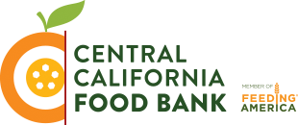

Central California Food Bank

Central California Food Bank keeps an updated food distribution calendar which can be found at <https://ccfoodbank.org/home/findfood/food-locator/food-distribution-calendar/>

Please share with patients who could benefit.

_______________________________________

Please note Perinatal Services Update will be taking a break for the months of December and January. We’ll start up in February of 2025.

**Perinatal Services Coordinator for the County of Fresno**

Yvonne Lopez, RN, PHN, CLC

Perinatal Services Coordinator

Main: 559-600-3330

Direct: 559-600-6387

Email: [yvolopez@fresnocountyca.gov](mailto:yvolopez@fresnocountyca.gov)