Group User Guide
CalMHSA Documentation Guide: Required Progress Note Service Information
- The type of service rendered
- A narrative describing the service, including how the service addressed the person’s behavioral health need (e.g., symptom, condition, diagnosis and/or risk factors).
- The date that the service was provided to the beneficiary.
- Duration of the service, including travel and documentation time, which should be documented separately.
- Location of the person in care at the time of receiving the service.
- A typed or legibly printed name, signature for the service provided and date of signature.
- ICD 10 code.44
- Current procedural terminology (CPT) or Healthcare Common Procedure Coding System (HCPCS) code.
- The plan, or next steps, including but not limited to, planned action steps by the provider or by the person in care, collaboration with the person in care, collaboration with other provider(s) and any update to the problem list as appropriate.
- For groups facilitated by multiple practitioners, a single progress note signed by one of the practitioners can be used to document the group service provided.
- Information about the specific involvement and specific amount of time of involvement of each practitioner in the group activity. Travel and documentation time should be captured separately
- A list of group participant names needs to be maintained. Please note, due to confidentiality standards, the full list of group participants must not be kept in any single participant’s personal health records: instead the MHP or practitioner must maintain the full participant list outside of any participant’s health records.

How to Set up a Group in SmartCare
- Click the Search icon.
- Type Managing into the search bar.
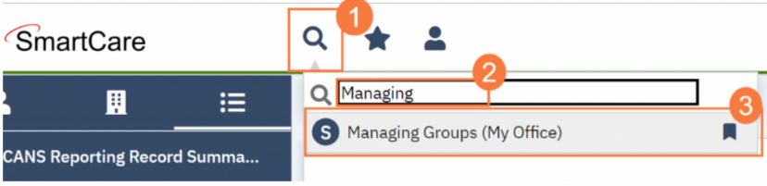
- Click to select Managing Groups (My Office).

- This takes you to the Managing Groups list page. Click the New icon.
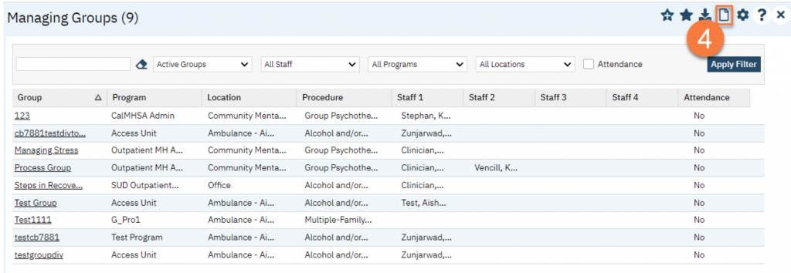

- This takes you to the Group Details screen. It is best to complete this screen from top to bottom. You will also not be allowed to move on to the Note tap until this Service time is completed. The following fields in bold are required. Enter the group’s name. This will auto-populate the “Display As” field, which you can change if necessary.
- In the Group Note drop-down, select “Group Progress Note”.
- Enter the mode of delivery.
- Enter the service information about the group in the Defaults section
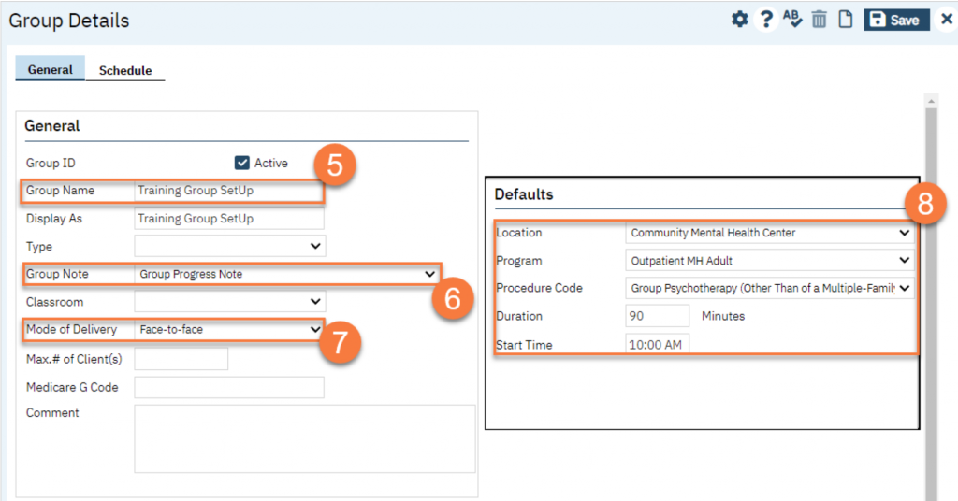

- Add Clients, as applicable. For some groups that are drop-in, you may not have any clients to include. If this is a closed group, or an ongoing group, we recommend adding the clients here. Click Add Clients. 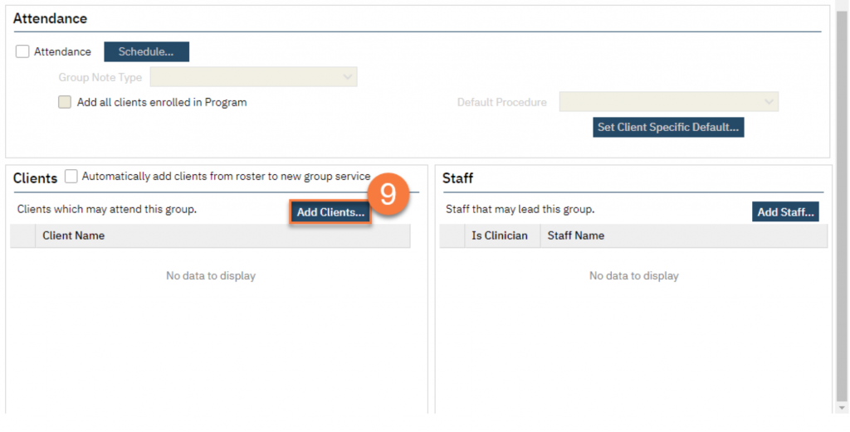
  - This brings up the client search pop-up. Search for the client you want to add to the group. Select the client from the Records Found section.
  - Click “Select.”
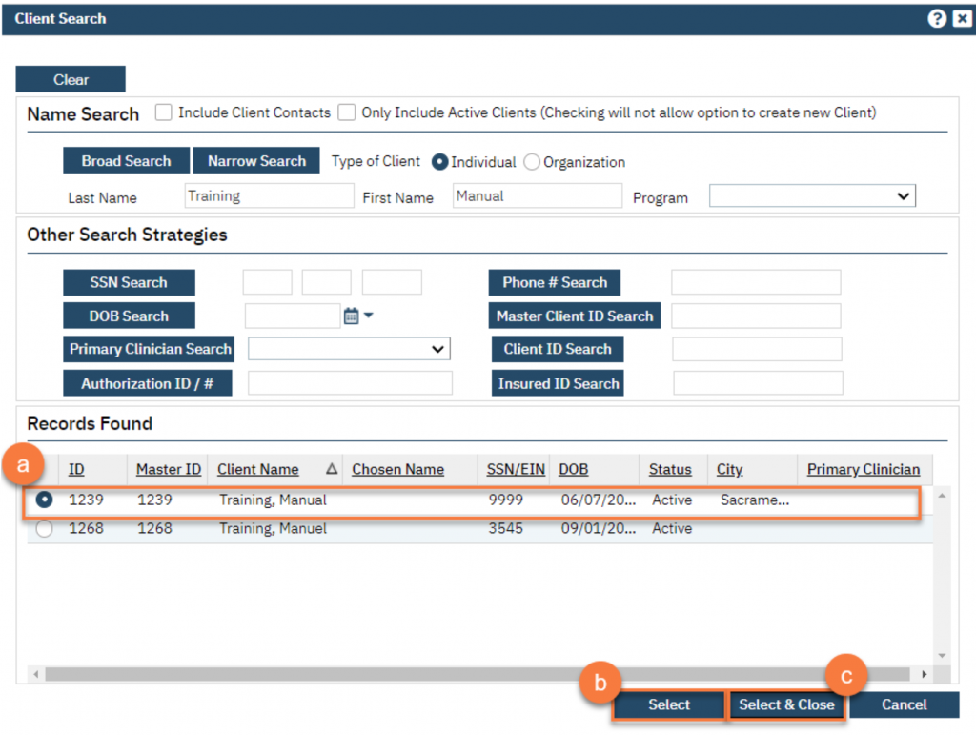
  - When you’ve finished adding all clients, you can click “Select & Close”.

- Add the group facilitators. You can have more than one facilitator. Click Add Staff.
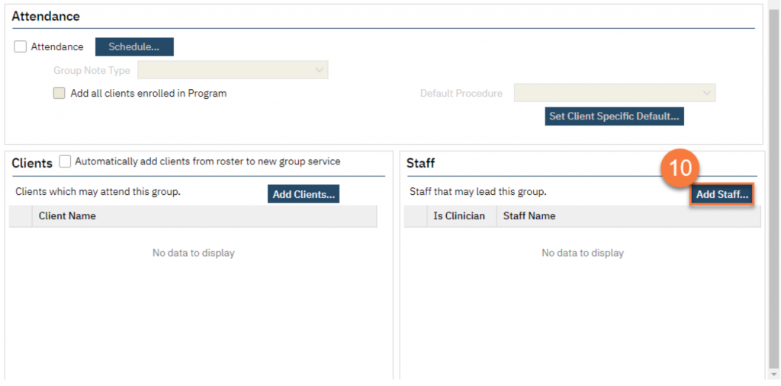

  - This brings up the Group Services Staff Pop Up. Select the facilitator(s) from the list.
  - Click OK.
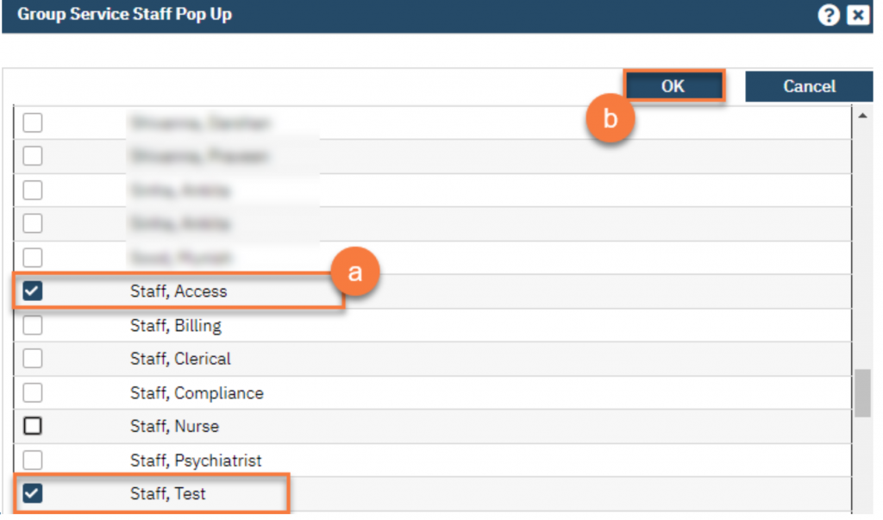
  - This takes you back to the Group Details page. Select the primary staff member by selecting them under “Is Clinician”.

- Click Save.
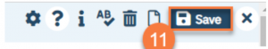
- Navigate to the Schedule tab.
- Click “New Group Service”
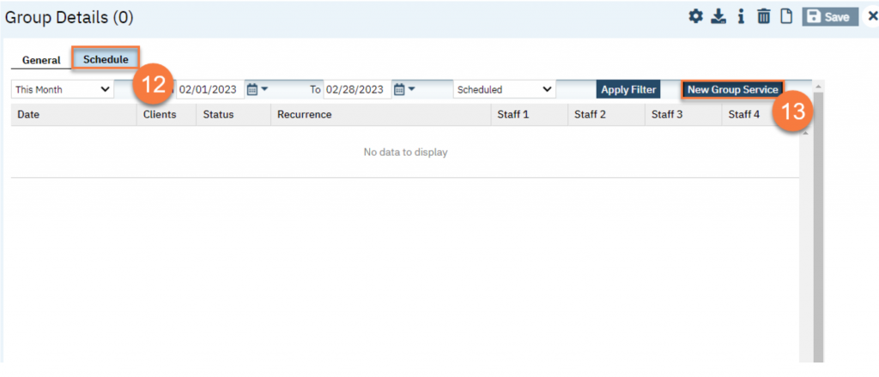
- This brings up the Group Service Client Popup window. Enter the first date of the group.
    - Select the clients you’re expecting to attend. You can click the top-most checkbox to select all the clients.
    - Click “Select.”
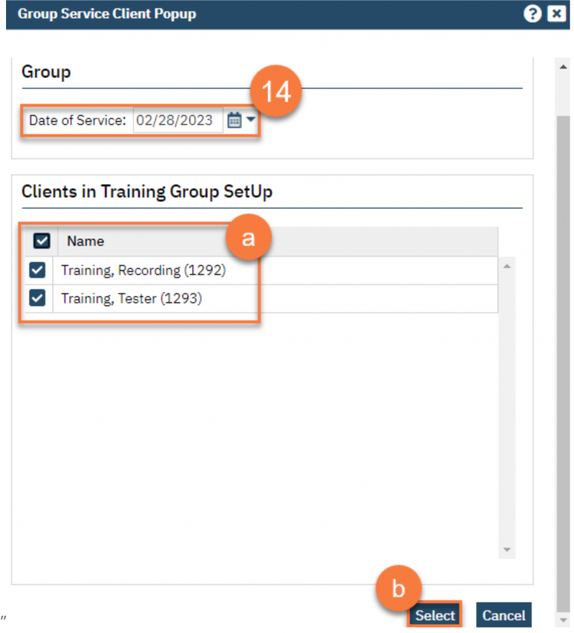

15. This takes you to the Group Service Detail screen. Confirm the group information. Enter the staff’s start time for both facilitators. This is a required field.
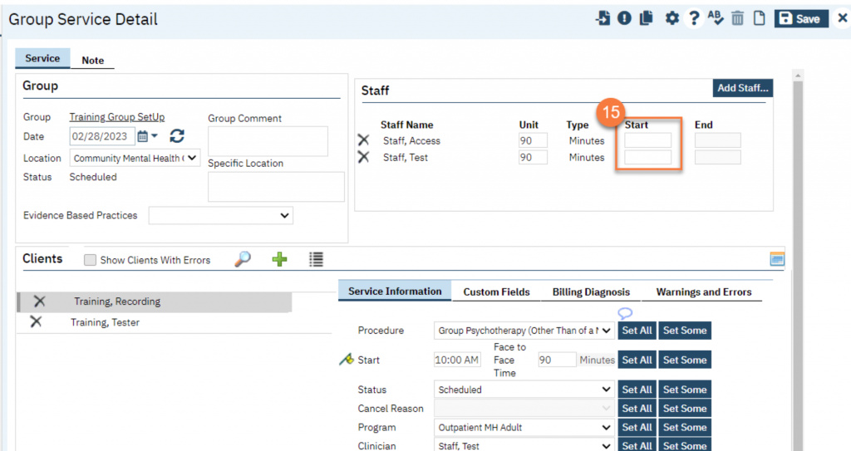
  - If any of the clients require transportation, make sure to enter that by clicking on the client’s name and entering their specific information in the service information section.
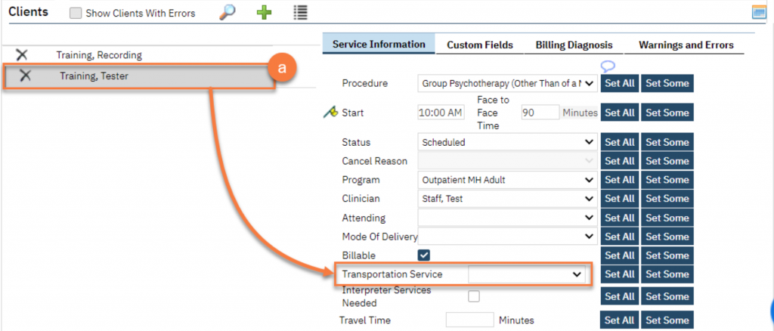

- Click Save.
- To set this up as a recurring group service, click the recurrence icon
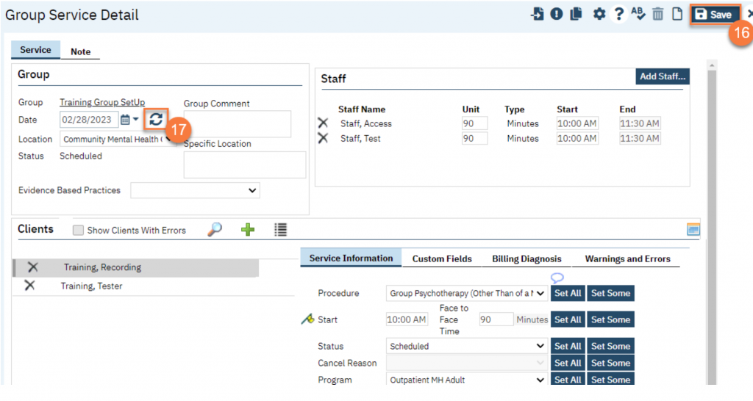
Important Note: If this is a closed group where group facilitators and group members will not often change then we recommend that you select the “Create Immediately” checkbox. Clicking the “Create Immediately” checkbox will create the specified series of events on the staff calendar. Keep in mind that by doing this any changes that need to be made to this series would need to be made individually and will not be pushed to the group recurrence. If you anticipate this to be an open group and there to be many group member changes and/or staff member changes then you would want to leave this option unchecked. That way when you make changes they will be pushed to future events. In this case, a place holder will be on the staff calendar instead of the actual event.
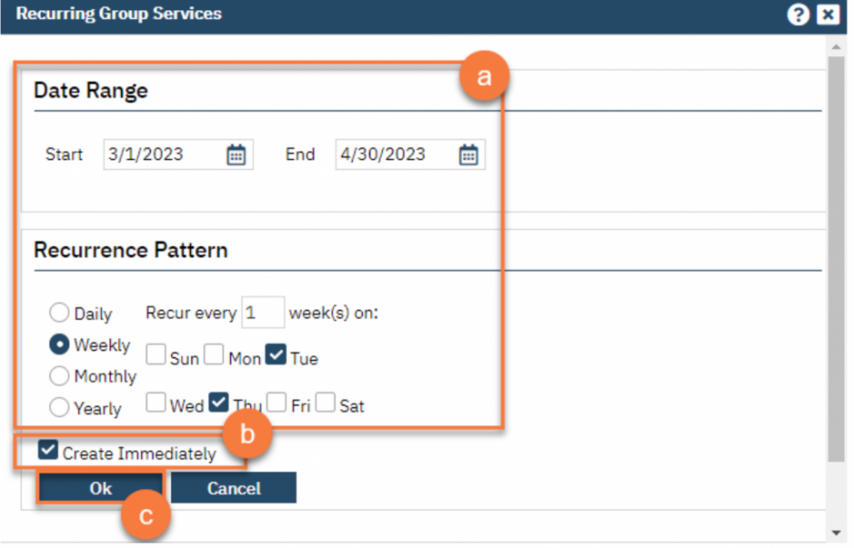
  - Click OK.

You are finished and may now click the X icon to close.
Documenting for Group Notes
- On your Appointments for Today widget, click on the link for the time of the group you’re documenting.
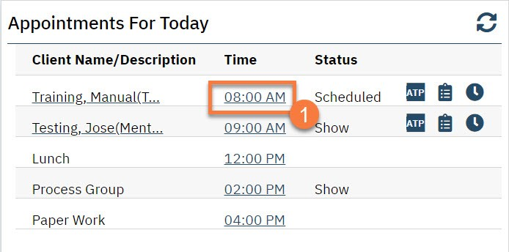
- This opens the Group Services Detail screen. In the upper left, you’ll see the group information. Confirm the information and add any additional information regarding the entire group.
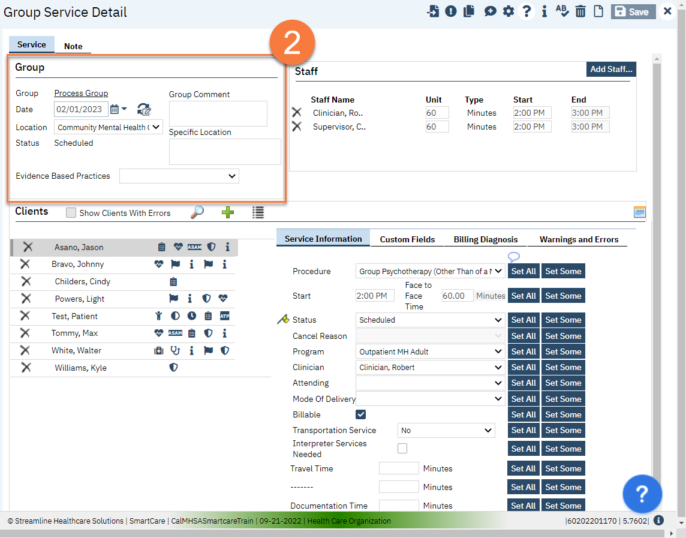

- In the upper right, you’ll see the staff members that are set as facilitators for this group.
  - Make edits to which staff members were present. For example, if a staff was only present for half of the group time, indicate this by editing the Unit (how many minutes they were present) and the Start Time to match what actually happened.
  - If a staff member was not present, click the Delete icon next to their name to remove them from this service.
  - If an additional staff member was present who is not listed, click the Add Staff button.
  - This brings up the Group Service Staff Pop Up. Select the staff member(s) you want to add and click OK.
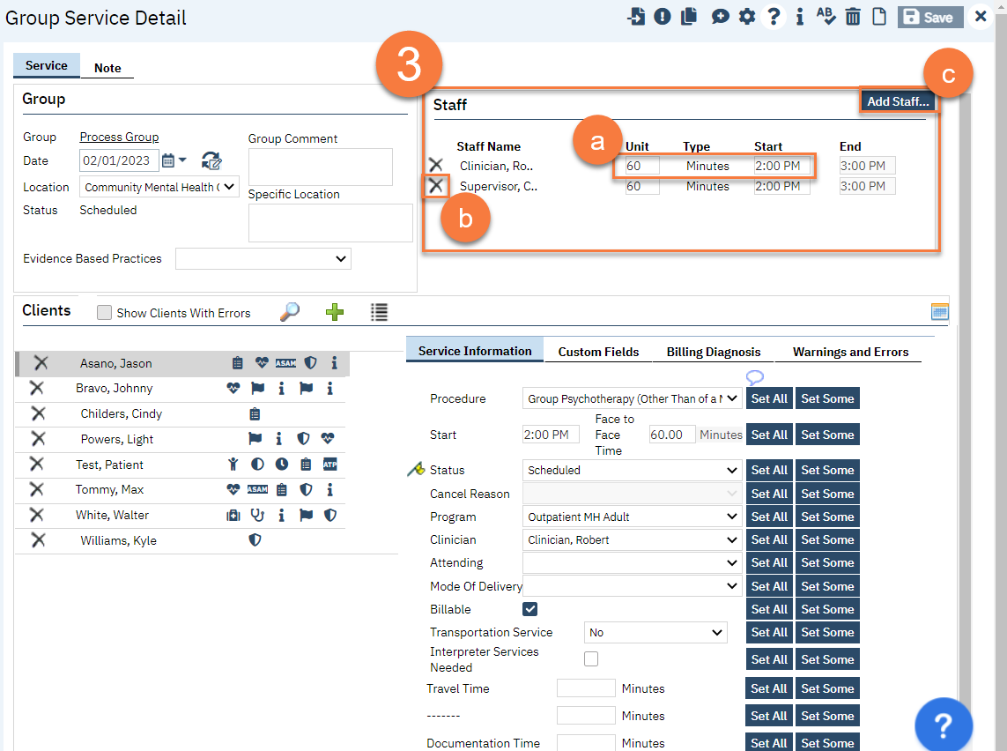

- On the middle left side of the screen, you’ll see the list of clients enrolled in this group. Make edits to this list to confirm the group roster.
  - To remove a client from the roster, click the Delete Service icon. DO NOT do this if they are simply a no-show. Only do this to remove them from this service’s roster entirely. Remember if this is a reoccurring group removing the client from here will only remove them for this service and not from future services. Please see below on how to do that.
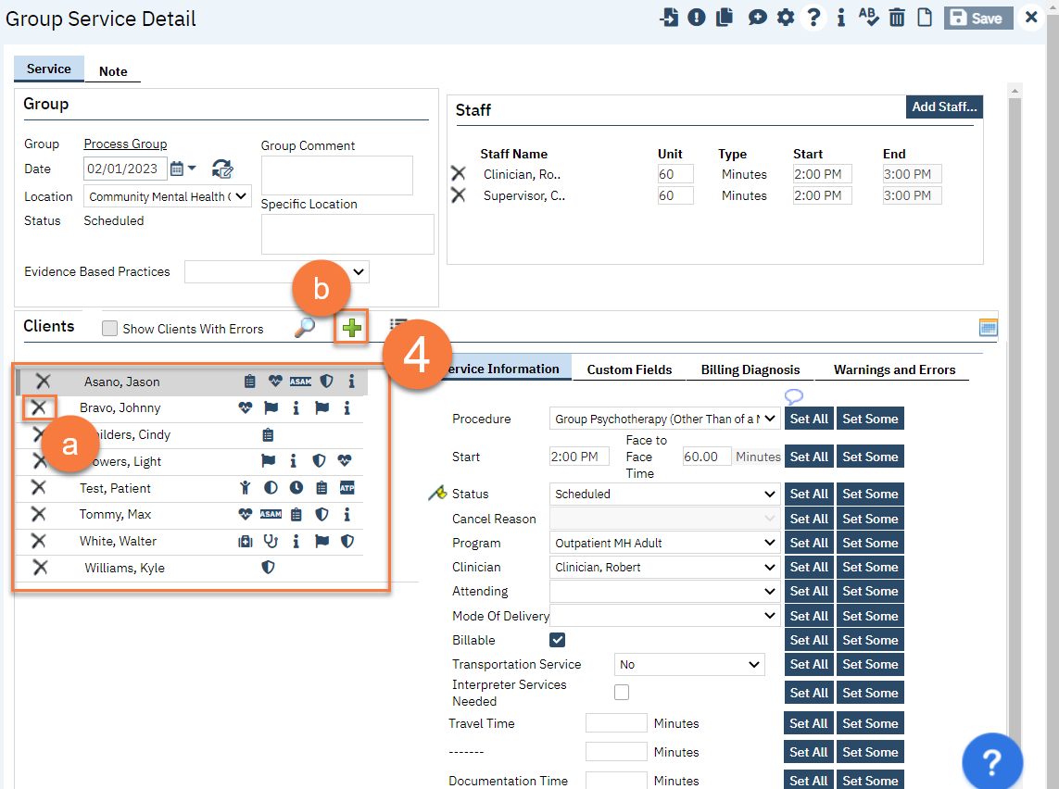
  - To add a client who has already been enrolled in this group, click the Plus icon.

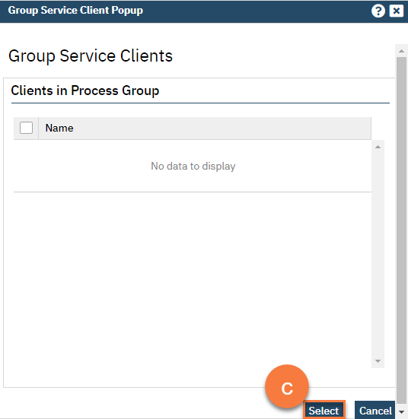
  - This will open up the Group Service Client Popup, which will list any additional clients that are enrolled in this group. Select the client and then click Select to add them to this service.

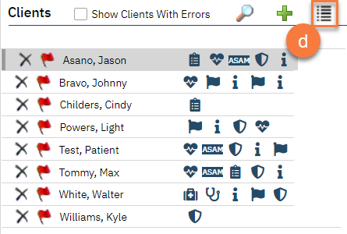
  - To add a client who is enrolled in this program but not yet enrolled in this group, click the List icon.

  - This will open up the Group Service Client Popup, which will list any clients that are enrolled in this program but are not yet enrolled in this group. Select the client(s) you want to add and click Select to add them to this service.
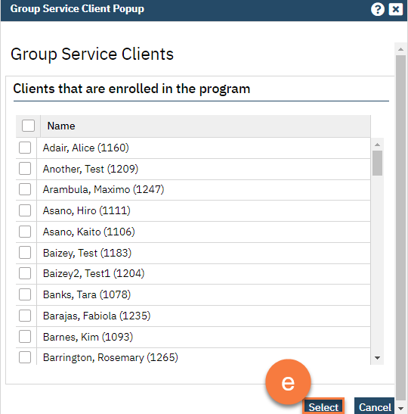

  - To add a client from another program, click on the Magnifying Glass icon.
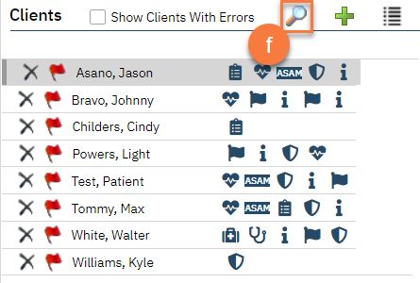
  - This will bring up the client search function. Search for the client you want to add and click Select & Close. If you want to add more than 1 client, you can simply click Select and then search for the next client you want to add.
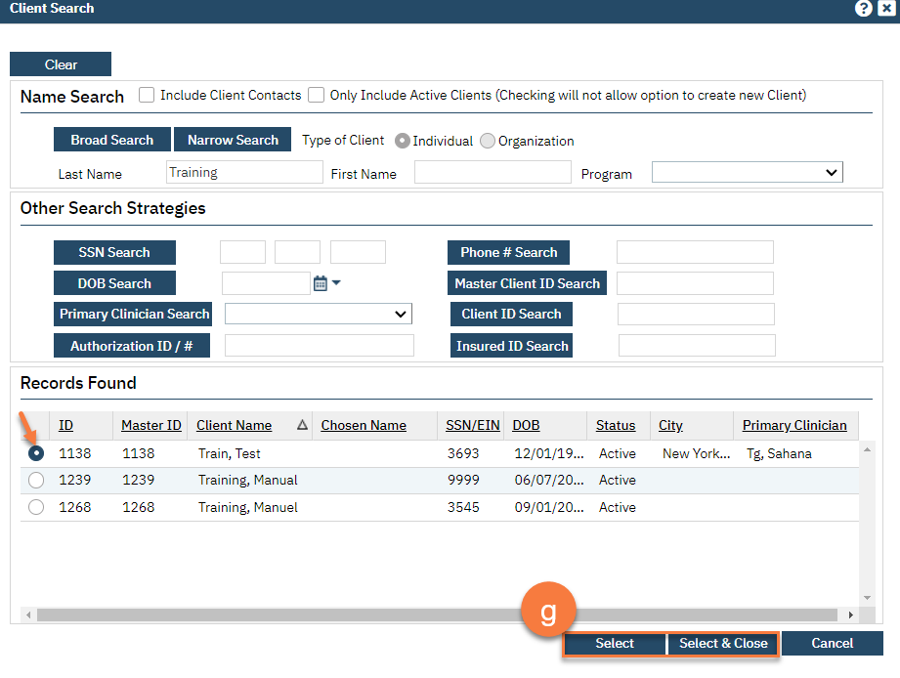

- Once you have your group roster set up, move to the service information section. The first client will be highlighted. As you make changes, this will update this particular client. This is where you mark whether clients who were a no-show for the group, or who canceled.
  - If you want to set this information for all of the clients, click the “Set All” button. You can do this for each item in the service information section.
  - If you want to set this information for more than one client, but not all of them, click the “Set Some” button.
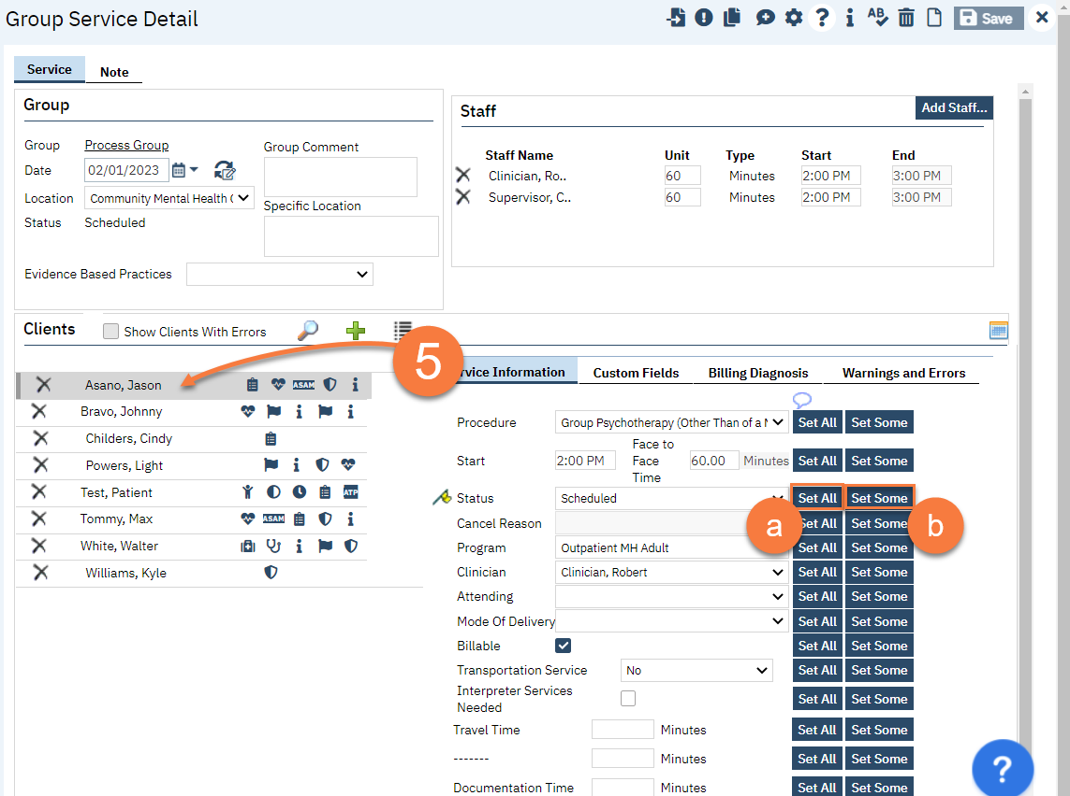

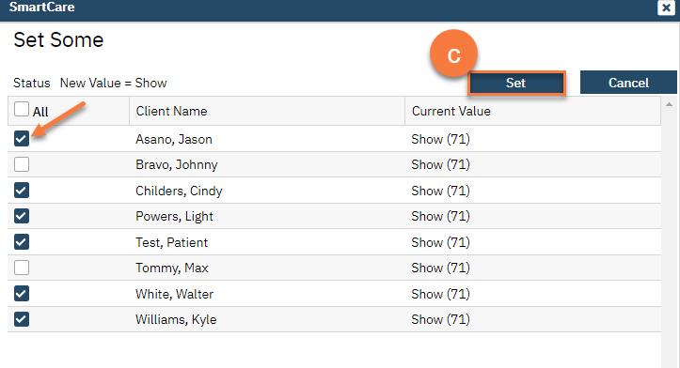
  - This will bring up the Set Some pop-up window. Select the clients you want to include in this change (e.g. all the clients who you want to mark as “show”). Then click Set.

If you hover your arrow above the yellow flag you will be able to see the each client and their information.
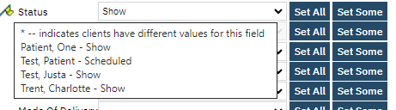

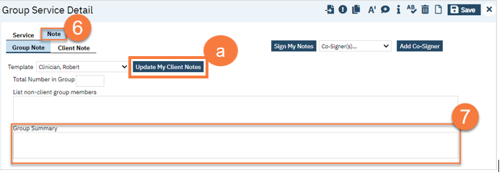
- Once you’ve completed the service information, navigate to the Note tab.

- Enter the group note summary.
  - Click the Update My Client Notes button. This will be pushed to all of the group member’s notes.
- Navigate to the Client Note tab.
- On the left side of the screen, select the client you’re writing the note for.
  - You can click on the checkbox “Only Show clients where I am the Note Author” to limit the clients on the list.
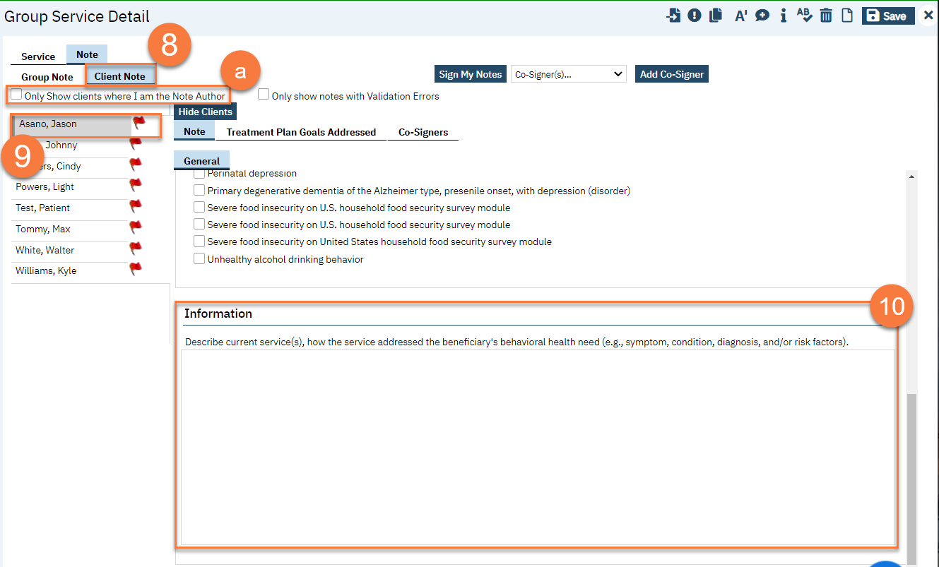
- On the right side of the screen, enter the individual client’s note for this group service.

- Add problems to the problem list as necessary. See Problem List for more information. After adding any problems, make sure to click Save.
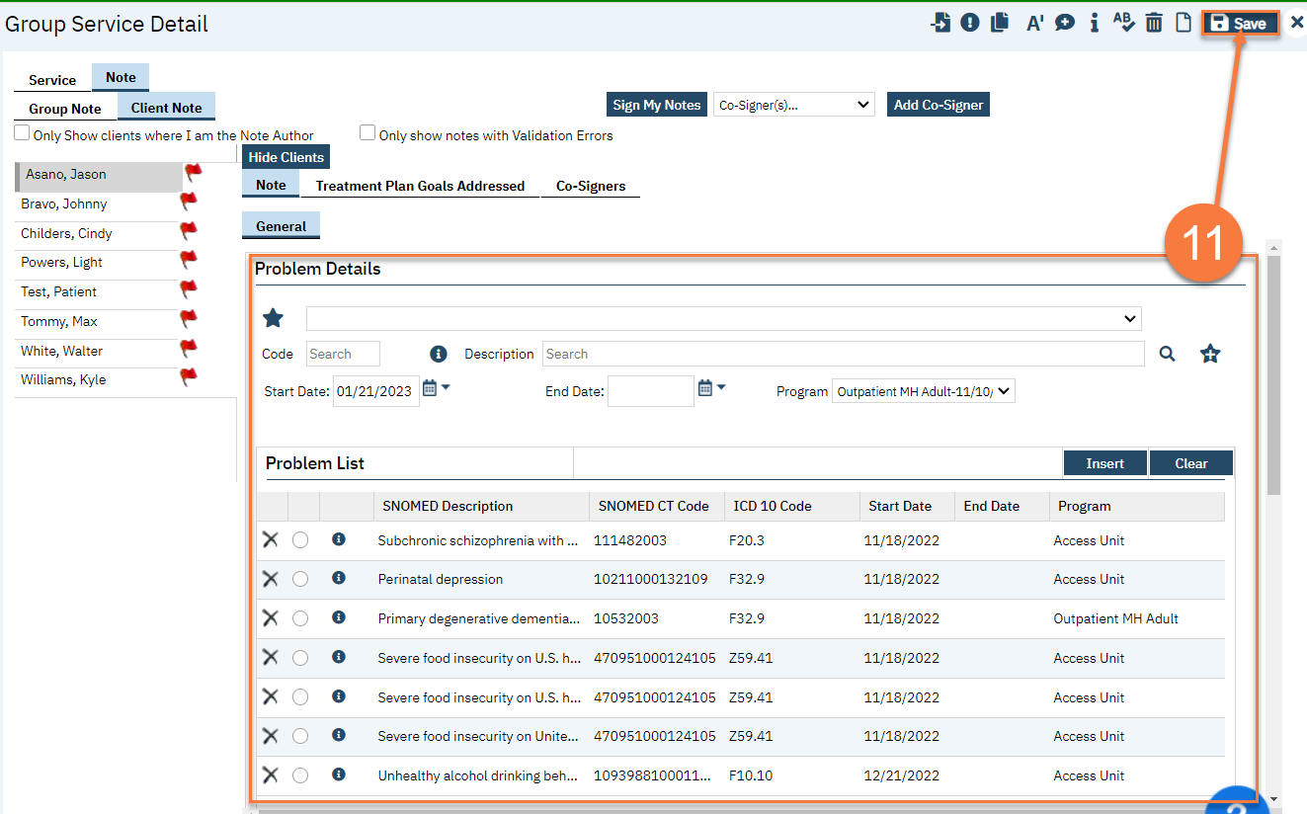
- Select problems that were addressed in today’s session. If you’ve added any problems to the problem list during this note writing, click Refresh to update this list.
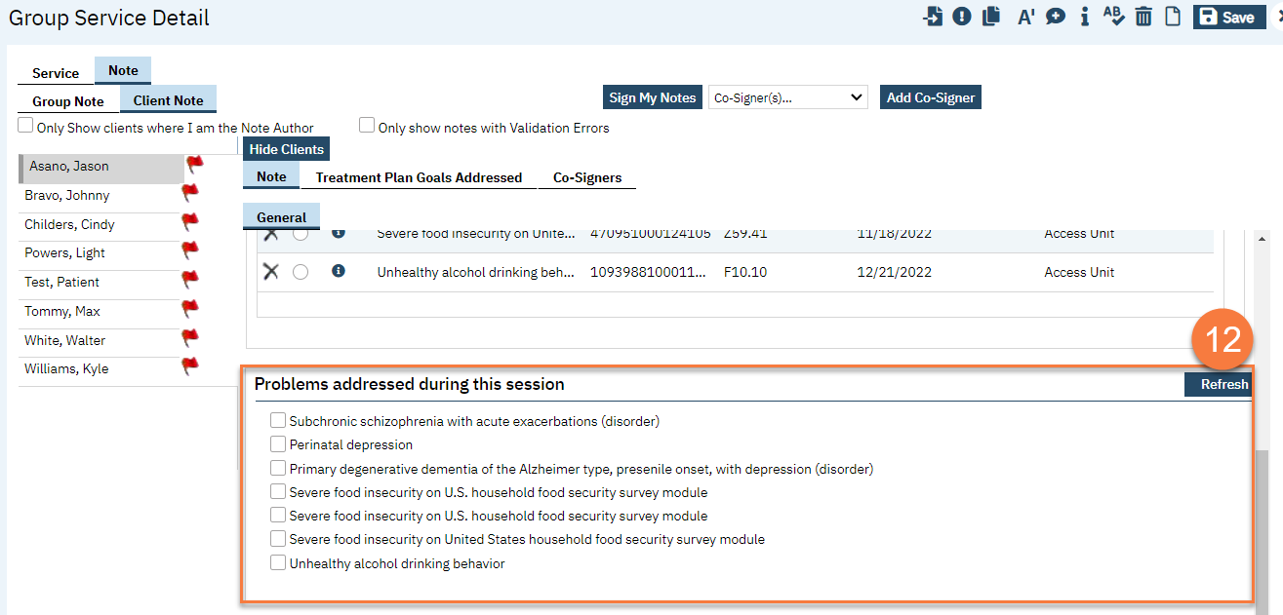
- To add Co-Signers as necessary, navigate to the Co-Signers tab.
  - Select the staff from the dropdown menu. This will add them to the list of people who will be asked to co-sign the note. Should this be included since it has been causing issues?
- Once you’re finished with all of your notes, click “Sign My Notes.”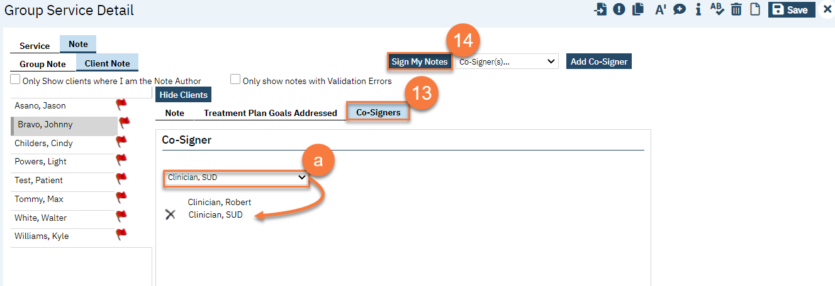
How to edit Group note (by doing this process you will delete the note and not edit it like you edit an individual note) You may need to copy the information that you may need.)
To edit a group note, follow the steps below:
1. Click the Search icon.
2. Type Managing into the search bar.
3. Click to select Managing Groups (My Office).
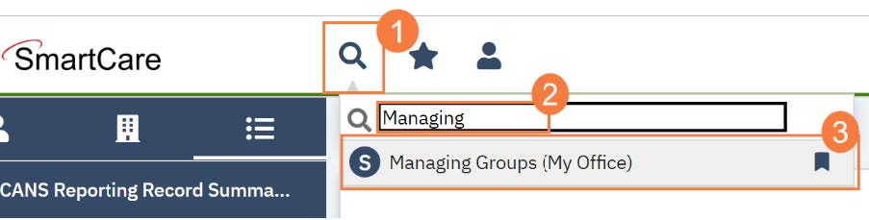
4. Click to select the Group you will be editing.
5.On the Group Service Detail click on the Error button that looks like an exclamation icon to mark it as error

6. This will remove the information on the Service Information field
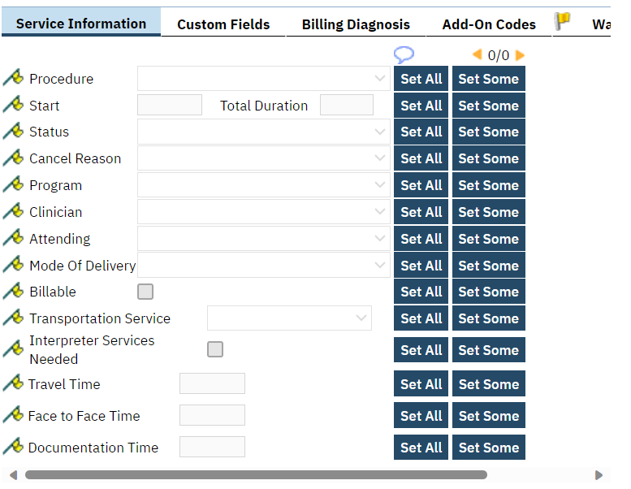
7. From here you can click on the delete button that looks like a trash can. If the group is set as a reoccurring group it will show you the message below. Make sure you mark the correct option for you need.
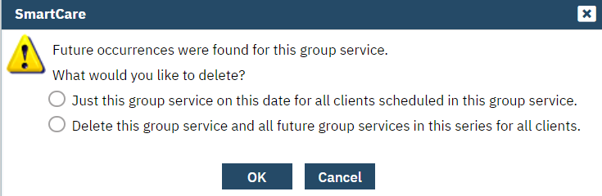
- You will need to reenter the service note you just deleted. You will return to Managing Groups, select the group, click the Schedule tab and click New Group Service to start the new group note.

How to Add a New Client to a Group
To add a new client to a Group, follow the steps below:
1. Click the Search icon.
2. Type Managing into the search bar.
3. Click to select Managing Groups (My Office).

4. Click to select the Process Group you will be adding the client to.
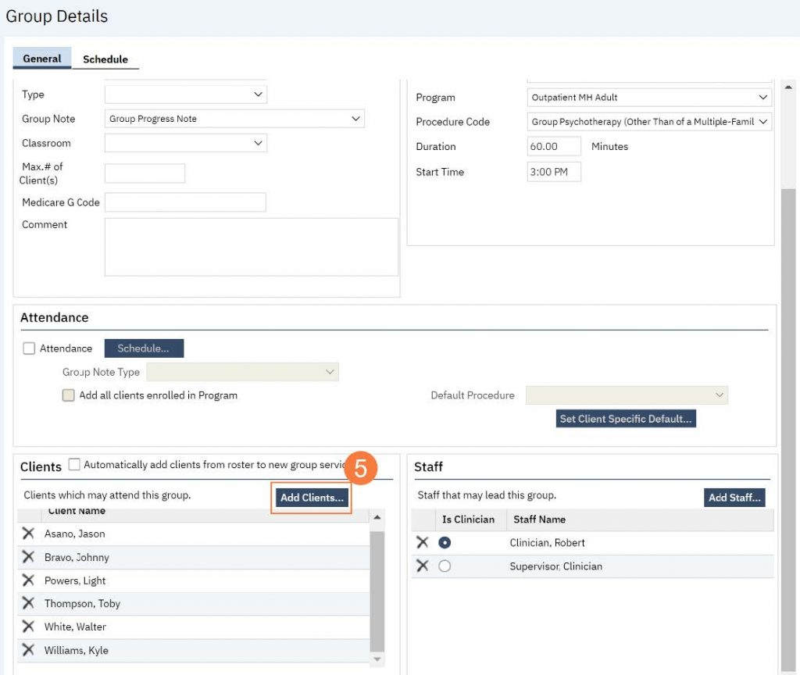
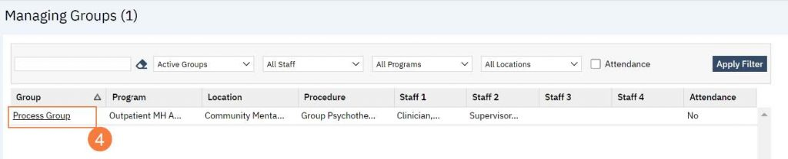
5. Locate the Client section towards the bottom of the Group Details screen. Click Add Clients.

6. The Client Search window will open, click in the Last Name and First Name fields to enter
the corresponding information. Select Enter on your Keyboard to populate search results.
a. You can also use the Other Search Strategies fields to search by SSN, DOB, etc.
7. Click the radio button to left of the client you want to select.
8. Click Select and Close. This client will be added to the group.
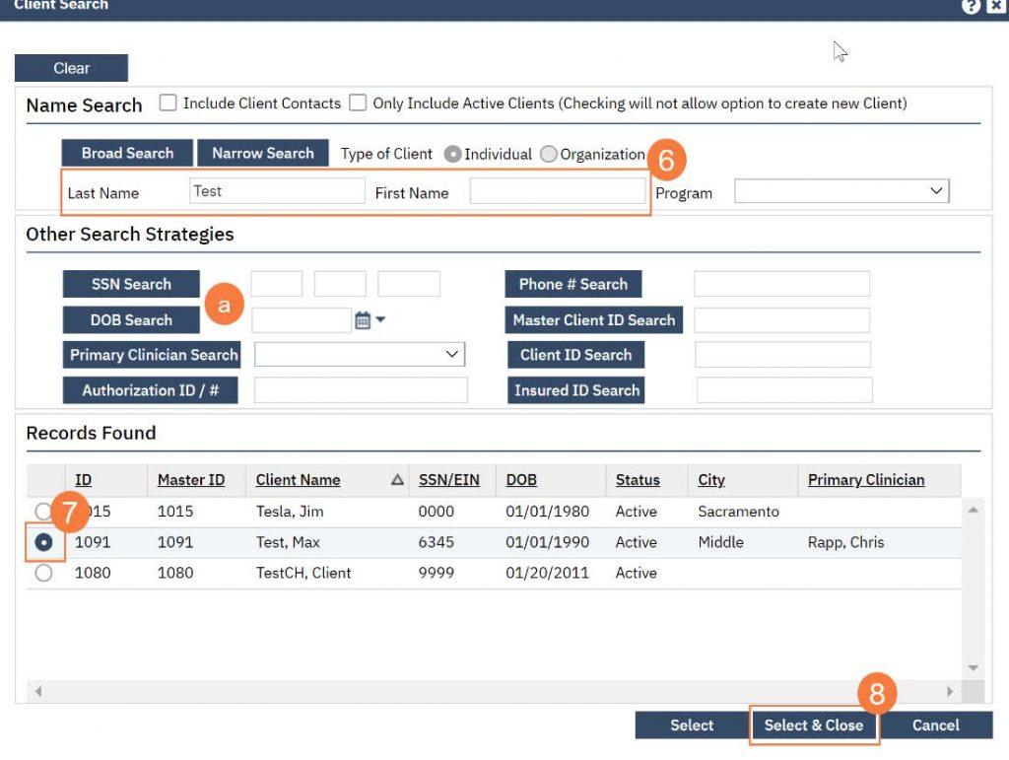
9. Click Save. Click the X to close the screen.
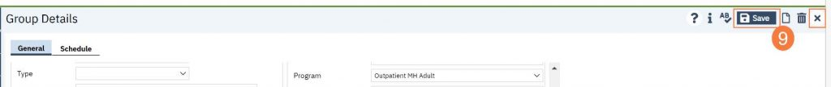

How to remove a client from a group

On the Group Service Detail screen locate the clients section

On the Clients Section you can click on the “X”

For clients that are in a group that is reoccurring you will get a message you stopped here.

How to Add or Change a Staff Member in a Group
To add or change a staff member in a group, follow the steps below:
1. Click the Search icon.
2. Type Managing into the search bar.
3. Click to select Managing Groups (My Office).
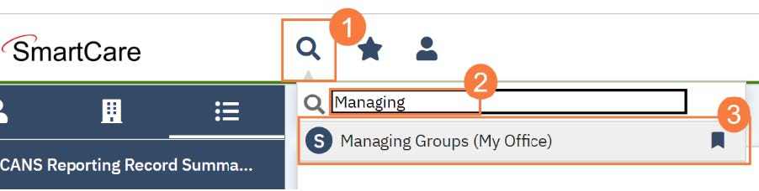
4. Click to select the Process Group you will be adding the client to.
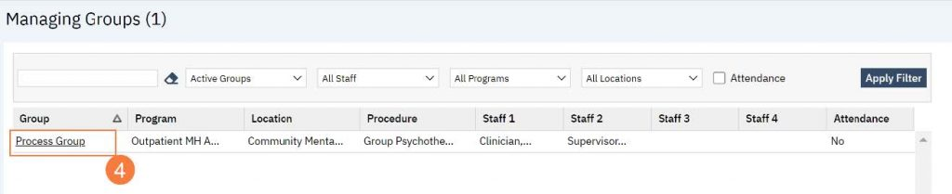
5. Locate the Staff section towards the bottom of the Group Details screen. Click Add Staff.
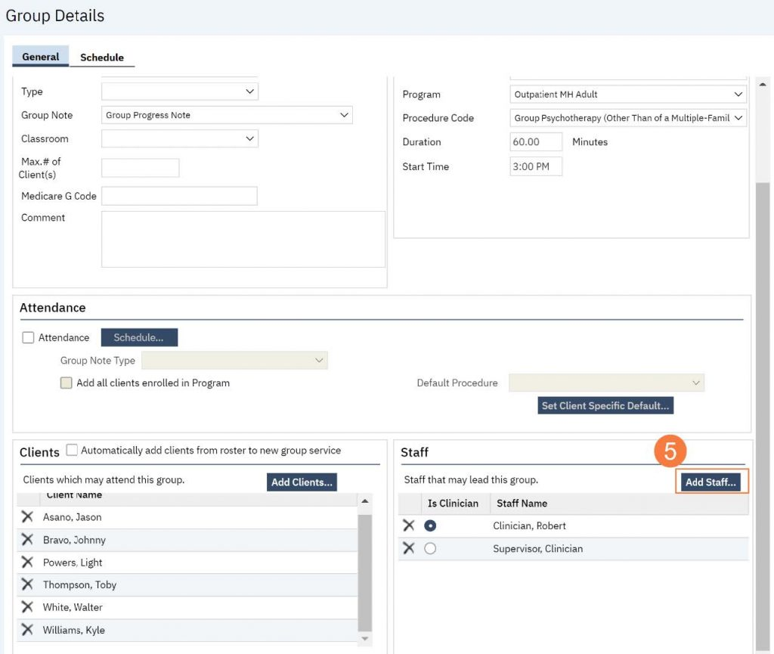
6. Click to select the correct staff member to add.
7. Click OK.
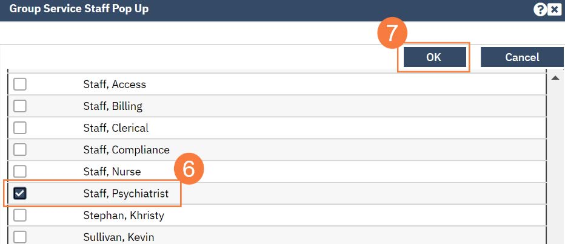
8. And/or, if you need to remove a staff member, click the X to the left of the staff member you want to remove.
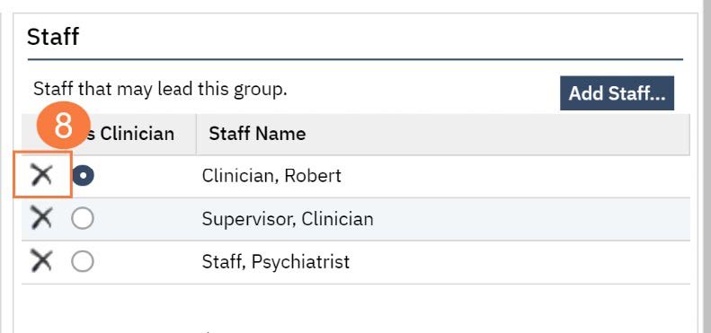
9. Click Save. Click the X to close the screen.

Procedure codes that may be used for DMC-ODS
Group Counseling | 7 | H0005 | DMC, DMC-ODS | Group Counseling | Group counseling related to alcohol and/or drug services. 15 minutes | AOD, LCSW, PCC(LPCC), MFT(LMFT),NP, PA, PSY(PSYD), RN
Peer Support Services | 19 | H0025 | DMC, DMC-ODS | Behavioral Health Prevention Education service | Skill building groups conducted by a Certified Peer Support Specialist. | Cert Peer
Therapy (MH), Family Therapy (DMC-ODS) | 63 | 90849 | MH, DMC-ODS | Multiple-Family Group Psychotherapy | A group therapy code that allows for documentation of groups that include multiple families vs. a single family. Therapy may be delivered to a beneficiary or group of beneficiaries and may include family therapy directed at improving the beneficiary’s functioning and at which the beneficiary is present. 15 minutes | CNS, DO, LCSW, PCC(LPCC),MD, MFT(LMFT), NP, PA, PHD, PSY(PSYD)
Rehabilitation (MH), Recovery Services (DMC-ODS) | 141 | H2017 | MH, DMC-ODS | Psychosocial Rehabilitation Group | For DMC-ODS, rehabilitation falls under Recovery Services and can document education related to mental health, substance abuse, independent living, social, coping and interpersonal skills, relapse prevention, etc. | AOD, Cert Peer, CNS, DO, LCSW, PCC(LPCC), LVN, MD, MFT(LMFT), MHRS, NP, OT, Other, PA, PHD, PSY(PSYD), PT, Pharm, RD

